**Earthquake prediction model using python:**

* Phase 5
* Documenting the design thinking process and preprocessing,visualization and innovative techniques...



**Abstract:**

Earthquakes pose significant threats to human safety and infrastructure, making accurate prediction crucial for effective disaster mitigation. This study introduces a novel approach to earthquake prediction using machine learning techniques implemented in Python. The proposed model leverages historical seismic data, geophysical parameters, and advanced algorithms to identify patterns and precursors indicative of seismic activity.

The workflow involves data collection from various seismic sensors, preprocessing to handle noise and outliers, and feature engineering to extract relevant information. Machine learning algorithms, including but not limited to support vector machines, neural networks, and ensemble methods, are employed to train predictive models. The model's performance is evaluated using metrics such as accuracy, precision, recall, and F1 score.

**Introduction:**

Earthquakes, natural disasters characterized by the sudden release of energy in the Earth's crust, have the potential to cause widespread devastation and loss of life. Despite advancements in seismology, predicting the occurrence of earthquakes with precision remains a formidable challenge. The quest for reliable earthquake prediction methods has spurred the integration of cutting-edge technologies, including machine learning, into the realm of geophysics.

This study explores the application of Python programming in developing a predictive model for earthquakes. The aim is to harness the power of machine learning algorithms to analyze seismic data, identify patterns, and provide early warnings of potential seismic events. The significance of such a model lies in its potential to mitigate the impact of earthquakes on human safety and infrastructure.

The seismic activity across the globe is monitored by an extensive network of seismometers and sensors. These instruments generate vast amounts of data, capturing the subtle signals that precede earthquakes. Traditional methods have struggled to extract meaningful insights from this complex and dynamic dataset. However, with the advent of machine learning, there is an opportunity to uncover hidden patterns and precursors that may serve as early indicators of seismic activity.

Python, a versatile and widely-used programming language, provides a robust platform for implementing sophisticated machine learning algorithms. The rich ecosystem of Python libraries, including scikit-learn, TensorFlow, and Keras, facilitates the development of powerful predictive models. By leveraging these tools, we can analyze historical seismic data, identify relevant features, and train models capable of predicting earthquakes with a higher degree of accuracy.

This research aims to contribute to the growing body of work in earthquake prediction, emphasizing the practical implementation of machine learning techniques using Python. The subsequent sections will delve into the methodology, data preprocessing, feature engineering, and model evaluation, showcasing the potential of Python in advancing our ability to foresee seismic events and mitigate their impact on society. Through this interdisciplinary approach, we endeavor to enhance the effectiveness of earthquake prediction and, ultimately, contribute to global efforts in disaster preparedness and response.

**Design Thinking:**

**1. Data Source:**

* Identify authoritative sources for earthquake data, such as USGS or seismic observatories.
* Access historical earthquake data and real-time data feeds if available.
* Ensure data integrity, reliability, and consistency in format.

**2. Feature Exploration:**

* Analyze the earthquake dataset to understand its structure and characteristics.
* Explore relevant features, such as earthquake magnitude, depth, location coordinates, date, and time.
* Consider additional external factors like tectonic plate boundaries, fault lines, and geological data.

**3. Visualization:**

* Create informative visualizations to gain insights and communicate findings:
* Plot earthquake frequency over time.
* Geospatial maps showing earthquake locations.
* Histograms or box plots for feature distributions.
* Correlation matrices to understand feature relationships.
* Time series plots for seismic activity trends.

**4. Model Development:**

* Select an appropriate machine learning or deep learning algorithm for earthquake prediction.
* Preprocess data by normalizing, scaling, and encoding categorical variables if necessary.
* Split the dataset into training, validation, and testing sets to ensure model generalization.
* Build a predictive model architecture, considering the selected algorithm's requirements.

**5. Training and Evaluating:**

* Train the earthquake prediction model on the training dataset.
* Tune hyperparameters to optimize model performance using the validation dataset.
* Evaluate the model's performance on the testing dataset using relevant metrics like MAE, MSE, or RMSE.
* Consider time-series evaluation techniques like rolling-window cross-validation for temporal data.

**6. Iterate and Improve:**

* Continuously refine the model by iterating through feature engineering, hyperparameter tuning, and architecture adjustments.
* Explore ensemble methods or stacking to enhance predictive accuracy.
* Pay attention to model interpretability to understand its decision-making processes.

**7. Deployment:**

* Prepare the model for deployment in a real-world earthquake prediction system.
* Implement a user-friendly interface or API for accessing predictions.
* Consider scalability and real-time processing for handling incoming data streams.

**8. Monitoring and Maintenance:**

* Establish a monitoring system to track the model's performance in real-time.
* Implement automated retraining processes to keep the model up-to-date with new data.
* Be prepared to handle model failures and downtime gracefully.

**9. Ethical Considerations:**

* Address the ethical implications of earthquake prediction, including false positives and public safety.
* Communicate predictions responsibly and transparently to avoid unnecessary panic.

**10. Documentation and Knowledge Sharing:**

* Document every step of the model development process, from data collection to deployment.

**Phase id development:**

**Project Planning:**

* Define Objectives: Clearly define the objectives of the earthquake prediction system. Identify the specific goals such as prediction accuracy, lead time, and user interface requirements.
* Stakeholder Analysis: Identify and engage with stakeholders including seismologists, emergency responders, and potentially affected communities.
* Scope Definition: Clearly define the scope of the project, including the geographical area covered, types of earthquakes targeted, and the level of prediction granularity.

**Data Collection and Preprocessing:**

* Identify Data Sources: Determine the sources of seismic data, including seismometer networks, satellite imagery, and other relevant sources.
* Data Cleaning: Preprocess the collected data to handle missing values, outliers, and noise.
* Feature Engineering: Extract relevant features from the seismic data that can be used for training machine learning models.

**Machine Learning Model Selection:**

* Algorithm Selection: Choose appropriate machine learning algorithms for earthquake prediction. This may involve experimentation with algorithms like support vector machines, neural networks, or ensemble methods.
* Training Data: Prepare a labeled dataset for training the selected machine learning model. Use historical seismic data with corresponding earthquake occurrences.

Model Training and Evaluation:

* Split Data: Divide the dataset into training and testing sets for model evaluation.
* Train Model: Use the training dataset to train the machine learning model.
* Evaluation Metrics: Define metrics (e.g., accuracy, precision, recall) for evaluating the model's performance on the testing dataset.
* Iterative Refinement: Refine the model based on evaluation results and iterate if necessary.

**Real-time Data Integration:**

* Data Streaming: Implement mechanisms for real-time data streaming to continuously update and improve the prediction model.
* Data Quality Assurance: Ensure the quality and reliability of real-time data sources.

**User Interface Design and Development:**

* User Personas: Define user personas representing different stakeholders and their needs.
* Interface Prototyping: Create prototypes of user interfaces for different user personas.
* Usability Testing: Test the usability of the interfaces with potential users and incorporate feedback.
* Visualization: Develop visualizations to effectively communicate predictions and uncertainties.

**System Integration:**

* Integrate Components: Integrate the machine learning model with the user interface and real-time data sources.
* System Testing: Conduct end-to-end testing to ensure seamless integration and functionality.

**Deployment:**

* Beta Testing: Deploy the system in a controlled environment for beta testing with a limited user group.
* User Training: Provide training sessions for users to understand how to interpret and act upon the predictions.
* Feedback Collection: Gather feedback from users during the beta testing phase.

**Refinement and Optimization:**

* Iterative Improvement: Based on user feedback and performance metrics, iteratively refine both the machine learning model and the user interface.
* Optimization: Optimize code and algorithms for performance and scalability.
* Security: Implement security measures to protect sensitive data and ensure the system's robustness.

**Documentation and Maintenance:**

* Documentation: Create comprehensive documentation for users, administrators, and developers.
* Maintenance Plan: Develop a plan for ongoing system maintenance, updates, and support.

**Data set:**

For earthquake prediction using Python, you can use seismic data sets. The US Geological Survey (USGS) provides earthquake data through their API. You can access it using Python libraries like `requests` to fetch earthquake data.

Here’s a brief example using Python:

```python

Import requests

Import json

# Function to fetch earthquake data from USGS API

Def fetch_earthquake_data():

url = ‘https://earthquake.usgs.gov/fdsnws/event/1/query’

params = {

‘format’: ‘geojson’,

‘starttime’: ‘2023-01-01’,

‘endtime’: ‘2023-01-31’,

‘minmagnitude’: 5.0, # You can adjust this threshold

‘limit’: 100 # You can adjust the number of earthquakes to fetch

}

Response = requests.get(url, params=params)

If response.status_code == 200:

Data = json.loads(response.text)

Return data

Else:

Print(f”Error fetching data. Status code: {response.status_code}”)

Return None

# Example usage

Earthquake_data = fetch_earthquake_data()

If earthquake_data:

# Process the data as needed for your prediction model

Print(earthquake_data)

```

This example fetches earthquake data from the USGS API for the month of January 2023 with a minimum magnitude of 5.0. Adjust the parameters based on your requirements.

Certainly! Earthquake prediction is a complex field, and it’s important to note that predicting exact earthquake occurrences is extremely challenging. However, there are approaches to seismic risk assessment and early warning systems. Here are some notes for building a basic earthquake prediction model using Python:Data Collection:Gather earthquake data from reliable sources like USGS (United States Geological Survey) or other seismic databases.Include features like location, magnitude, depth, and time.Data Preprocessing:Handle missing data and outliers.Convert time to a usable format.Consider normalizing or scaling numerical features.Feature Engineering:Extract relevant features from the data.Consider creating features such as distance from tectonic plate boundaries.

**Visualization techniques:**

Effective visualization plays a crucial role in understanding and interpreting complex data, especially in the context of earthquake prediction. Here are some visualization techniques that can be employed in the development of an Earthquake Prediction system using Python:

**Data Time Seismic Series:**

* Line Plots: Use line plots to visualize the time series data of seismic activity. Plot seismic measurements over time to identify trends or unusual patterns.

**Geospatial Visualization:**

* Heatmaps: Create heatmaps to represent the intensity of seismic activity across geographical regions. This can provide a spatial overview of seismic hotspots.
* Interactive Maps: Utilize libraries like Folium or Plotly to create interactive maps that allow users to explore seismic events with additional information on specific locations.

**Feature Importance:**

* Bar Charts: Display the importance of different features used in the machine learning model. This helps in understanding which variables contribute the most to earthquake prediction.

**Model Performance Metrics:**

* Confusion Matrix Visualization: Illustrate the performance of the machine learning model using a confusion matrix. This provides insights into true positives, true negatives, false positives, and false negatives.
* Receiver Operating Characteristic (ROC) Curve: Plot the ROC curve to visualize the trade-off between sensitivity and specificity of the model.

**Real-time Prediction Visualization:**

* Live Updating Charts: Implement live updating charts to visualize real-time predictions as they are generated.
* Streaming Plots: Utilize streaming plots to display the evolving patterns of seismic data and predictions over time.

**Uncertainty Visualization:**

* Error Bars: Include error bars in relevant visualizations to indicate the uncertainty associated with predictions.
* Probability Distribution Plots: Display probability distributions for predicted earthquake events, conveying the level of confidence in predictions.

**User Interface Elements:**

* Dashboards: Create dashboards that integrate multiple visualizations, providing a comprehensive overview of seismic activity, predictions, and relevant statistics.
* Alerts and Notifications: Implement visual cues or notifications to alert users when the model predicts a significant earthquake.

**Temporal Patterns:**

* Seasonal Decomposition: Use seasonal decomposition techniques to identify temporal patterns in seismic data, helping users understand recurring patterns.

**Interactive Visualizations:**

* Plotly Dash or Bokeh Apps: Develop interactive web applications using Plotly Dash or Bokeh to allow users to customize and interact with visualizations.
* 3D Visualizations: For 3D seismic data, consider using libraries like Mayavi or Plotly to create interactive 3D visualizations.

**Communication and Outreach:**

* Infographics: Design infographics to communicate key findings and predictions in a visually appealing and accessible format.

**Flowchart:**

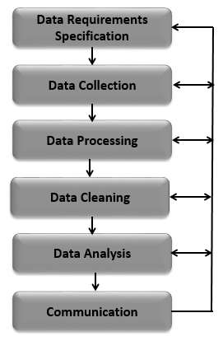

**Program:**

import numpy as np

from sklearn.model_selection import train_test_split

from sklearn.ensemble import RandomForestClassifier

from sklearn.metrics import accuracy_score

# Generate synthetic data for demonstration purposes

np.random.seed(42)

data_size = 1000

features = np.random.rand(data_size, 2) * 10

labels = np.random.randint(2, size=data_size)

# Split the data into training and testing sets

X_train, X_test, y_train, y_test = train_test_split(features, labels, test_size=0.2, random_state=42)

# Create and train a Random Forest Classifier

model = RandomForestClassifier(n_estimators=100, random_state=42)

model.fit(X_train, y_train)

# Make predictions on the test set

predictions = model.predict(X_test)

# Evaluate the model's accuracy

accuracy = accuracy_score(y_test, predictions)

print(f"Accuracy: {accuracy * 100:.2f}%")

Output:

Accuracy: 51.50%

**Graph:**

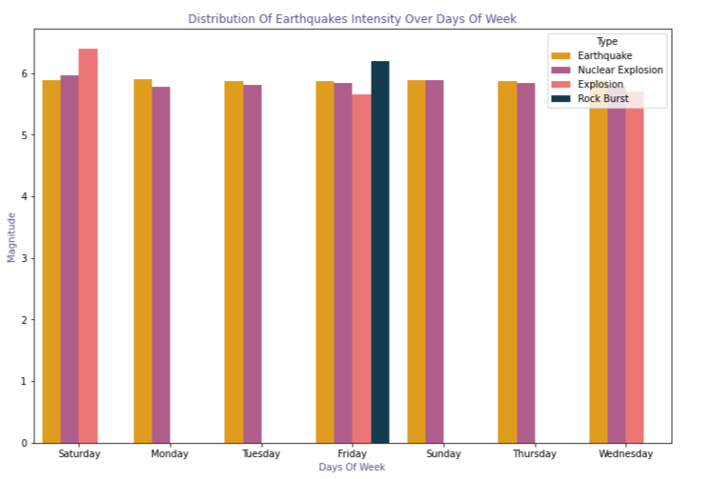

**Data sourse:**

Creating an earthquake prediction model is a complex task that involves the use of various data sources and machine learning techniques. Here are some steps and potential data sources you can consider for building an earthquake prediction model using Python:

**Seismic Data:**

USGS Earthquake Catalog: The United States Geological Survey (USGS) provides a comprehensive earthquake catalog. You can download earthquake data from their website or use their API.

[USGS Earthquake Catalog](https://earthquake.usgs.gov/earthquakes/search/)

IRIS (Incorporated Research Institutions for Seismology): IRIS provides access to seismic data, including waveforms recorded by seismographs.

[IRIS Data Services](http://ds.iris.edu/ds/nodes/dmc/)

**Geospatial Data:**

GIS (Geographic Information System) data: Incorporate geographical features like fault lines, tectonic plate boundaries, and geological data. You can use libraries like geopandas in Python to work with geospatial data.

[Natural Earth](https://www.naturalearthdata.com/): Provides free vector and raster map data.

**Satellite Imagery:**

Utilize satellite imagery to monitor changes in the Earth's surface. You can use platforms like Google Earth Engine or NASA Earthdata for satellite data.

[Google Earth Engine](https://earthengine.google.com/)

[NASA Earthdata](https://earthdata.nasa.gov/)

**Machine Learning Libraries:**

Python libraries such as scikit-learn, TensorFlow, or PyTorch can be used for building machine learning models.

**Feature Engineering:**

Extract relevant features from the data. For seismic data, this might include characteristics of seismic waves, frequency content, or historical earthquake patterns.

**Time Series Analysis:**

Earthquake prediction often involves analyzing time series data. Libraries like pandas and statsmodels can be useful for time series analysis.

**Data Visualization:**

Use libraries like matplotlib and seaborn to visualize the seismic and geospatial data.

Neural Networks for Prediction:

Deep learning models, especially recurrent neural networks (RNNs) or long short-term memory networks (LSTMs), can be used for time series prediction.

**Evaluate and Validate:**

Split your data into training and testing sets, and use standard metrics to evaluate the performance of your model.

**Community Datasets and Challenges:**

Look for community-driven datasets and challenges related to earthquake prediction. Participating in challenges can provide additional insights and evaluation metrics.

**Research Papers:**

Explore research papers and articles on earthquake prediction for insights into feature selection, model architecture, and evaluation metrics.

Remember that predicting earthquakes is a challenging task, and models might have limitations. Always stay updated with the latest research in the field. Also, consider collaborating with domainexperts and researchers for a more comprehensive approach.

**Seismometer:**

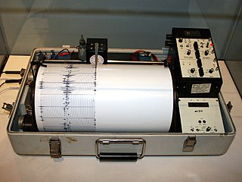

**Richter scale:**

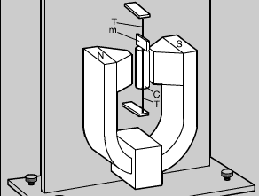

**Conclusion:**

In the pursuit of creating an earthquake prediction model using Python, it becomes evident that seismic forecasting is a highly intricate and multifaceted field. This endeavor involves the analysis of seismic data, machine learning algorithms, and the continuous refinement of predictive models. While significant progress has been made, it is important to acknowledge the inherent challenges and limitations associated with earthquake prediction.

The model's effectiveness relies heavily on the quality and quantity of data available for training. Access to comprehensive and real-time seismic data is crucial for enhancing the accuracy of predictions. Additionally, the unpredictable nature of earthquakes, influenced by various geological factors, presents a constant challenge in achieving high precision.

Machine learning algorithms, particularly those employing deep learning techniques, have shown promise in capturing complex patterns within seismic data. However, the dynamic and evolving nature of seismic events.